MindGenius Online for Microsoft Teams Guide
Getting Started & Usage
Configuration & Rollout
Customer Support for End-Users and IT Admins
Table of Contents
Getting Started & Usage 2
Introduction 2
Overview of MindGenius Online in Teams 2
Getting started & usage guidance for Teams users 4
Prerequisites 4
Add MindGenius Online to Teams 4
Sign into MindGenius Online 5
Start using MindGenius Online 8
Additional resources 8
Configuration & Rollout 9
Introduction 9
Overview of MindGenius Online in Teams 9
Configuration & rollout guidance for Microsoft 365 administrators 10
Prerequisites 10
Sign into the Microsoft Teams admin center 10
Set Global (org-wide) app permission policies 12
Enable MindGenius Online in Teams 13
Troubleshooting and additional resources 15
MindGenius Online for Microsoft Teams Customer Support for End-Users and IT Admins 16
Where can end-users of Microsoft Teams get customer support for your app? 16
What SLA do you have for responding to end-user raised customer issues via your support channel? 16
What is the escalation matrix for end-users to get faster response and resolution for their issues/queries? 16
Where can IT Admins of Microsoft Teams customer organizations get support for your app? 16
What SLA do you have for responding to IT admin raised customer issues via your support channel? 16
What is the escalation matrix for IT Admins to get faster response and resolution for their issues/queries? 16

Getting Started & Usage

Introduction
This document provides guidance for Microsoft Teams end users to get started and use MindGenius Online in Microsoft Teams.

Overview of MindGenius Online in Teams

Microsoft Teams together with MindGenius provide the ideal platform to let interested parties identify, collaborate and prioritize where effort is best rewarded. Helps ensure we continually do the right things and do them right.

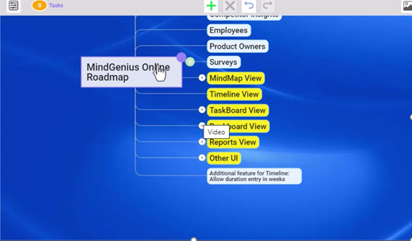
Create a unique workspace for you and your team to collate and develop ideas Capture ideas and information Quickly group and order information using drag and drop Effortlessly add new information

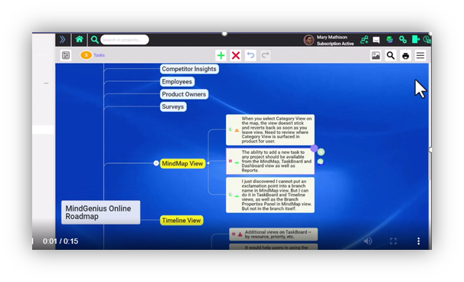
Organize, evaluate, and prioritize according to your criteria, using a variety of powerful visual tools Assign categories to quickly sort and sequence the information and ideas – based on impact and difficulty (in this example) Use the Tag Centric View to see where impact and difficulty can help you define the sequence of tasks Focus on the best ideas

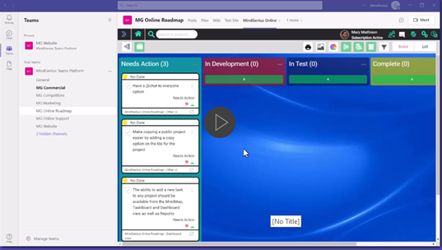
Turn ideas into actions — highlighting what's most important, what's needed when, and everyone's workload Define your key process stages to ensure tasks are managed to completion Arrange tasks by your criteria Drag and drop tasks to track progress

Getting started & usage guidance for Teams users

Prerequisites
- Active Teams account
- Active MindGenius Online account

Add MindGenius Online to Teams
- Open Teams and sign in.

- Select the Apps icon on the left rail of the Teams window.
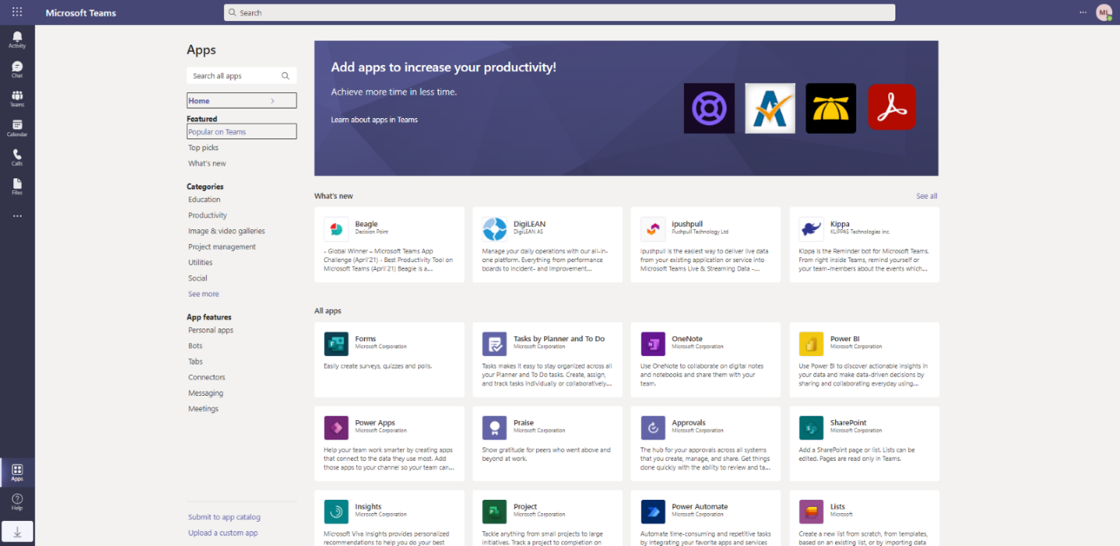

- Search for MindGenius Online

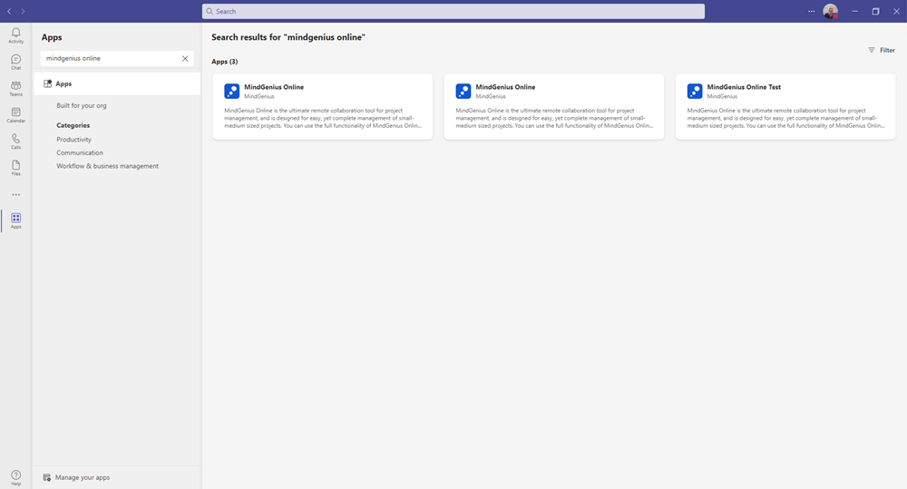

- Click on the application and press the Add button.

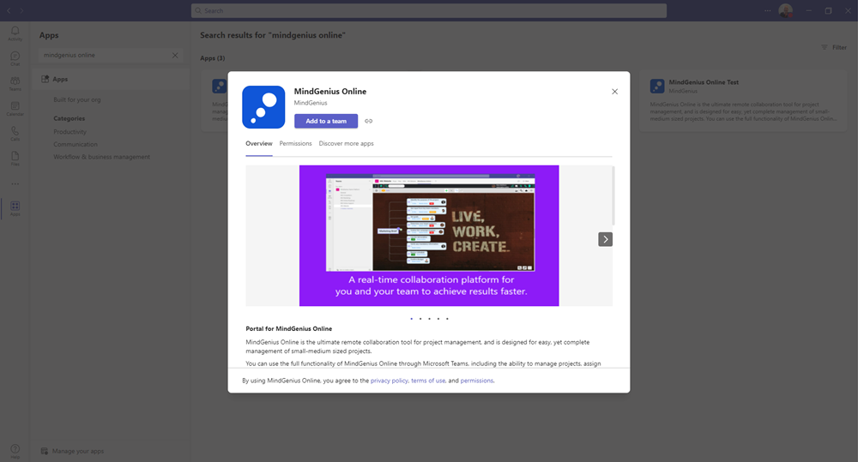

Sign into MindGenius Online
- Choose which of your teams you would like to add MindGenius too. Type a new team name or add to one of you current Team or Channel name

MindGenius will be available for the entire team, but start by setting it up in a channel. Type the team or channel name and select set up a tab

When you set up a tab there are a number of options available

- Use Full App enables all the feature views to be available within the tab
- Select a Project/Quickmap allows the option of a specific Project or Quickmap to be viewable for the team as a separate tab.

If you select this option then open up the dropdown to decide which Project/Quickmap to be added to the tab

Once the required Project or Quickmap has been selected from the drop down then choose if you require the map view or the taskboard view be added to the tab. Select Save

If you select map a tab will be visible to all members of the team

If you select taskboard a tab will be visible to all members of the team

Start using MindGenius Online

- Drive meaningful meetings with clarity on current status, priority and next steps
- Use collaborative brainstorming to capture ideas and information
- Assign categories to quickly sort and sequence the information and ideas
- Arrange tasks by your criteria and drag and drop tasks to track progress

Additional resources

- Short video demonstrating how MindGenius within teams can be used to brainstorm and agree the priorities for the product roadmap for next quarter when considering ideas from several different sources – Watch video
- Best practice tips in short video format – Visit Website

Configuration & Rollout

Introduction
This document provides guidance for Microsoft 365 IT administrators to configure and govern the roll out of MindGenius Online in Microsoft Teams. This document also includes information for Teams users to get started with MindGenius Online.

Overview of MindGenius Online in Teams

Microsoft Teams together with MindGenius provide the ideal platform to let interested parties identify, collaborate and prioritise where effort is best rewarded. Helps ensure we continually do the right things and do them right.

Create a unique workspace for you and your team to collate and develop ideas Capture ideas and information Quickly group and order information using drag and drop Effortlessly add new information

Organize, evaluate, and prioritize according to your criteria, using a variety of powerful visual tools Assign categories to quickly sort and sequence the information and ideas –based on impact and difficulty (in this example) Use the Tag Centric View to see where impact and difficulty can help you define the sequence of tasks Focus on the best ideas

Turn ideas into actions — highlighting what's most important, what's needed when, and everyone's workload Define your key process stages to ensure tasks are managed to completion Arrange tasks by your criteria Drag and drop tasks to track progress

Configuration & rollout guidance for Microsoft 365 administrators

Prerequisites
Prior to configuring and rolling out MindGenius Online in Microsoft Teams, ensure that you have:
- An active Microsoft 365 subscription
- Access to a Microsoft 365 administrator account
- Activated Microsoft Teams for your organization
- An active MindGenius Online subscription

Sign into the Microsoft Teams admin center
- Go to https://admin.teams.microsoft.com/

- Enter your administrator credentials
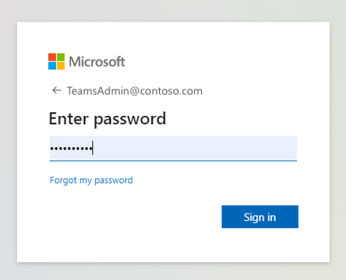

- Access the Teams admin center dashboard.

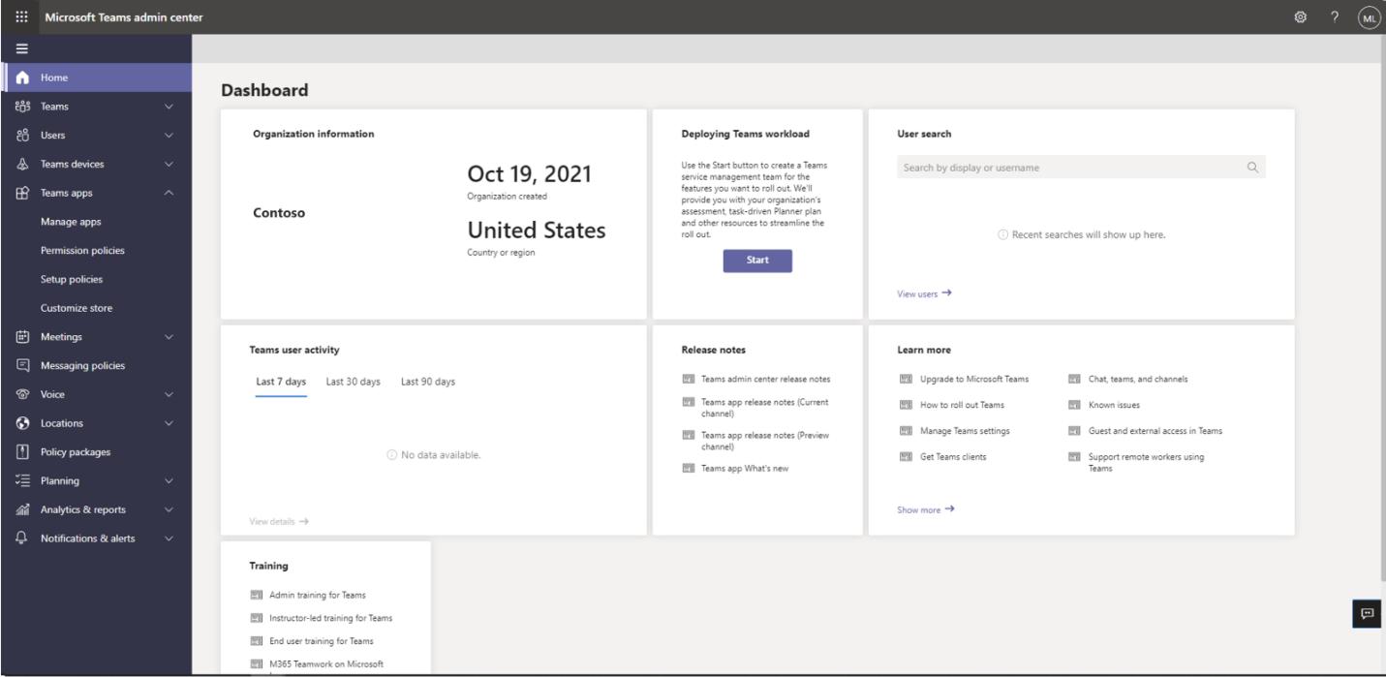

Set Global (org-wide) app permission policies

- Select the Teams apps dropdown followed by Permission policies.

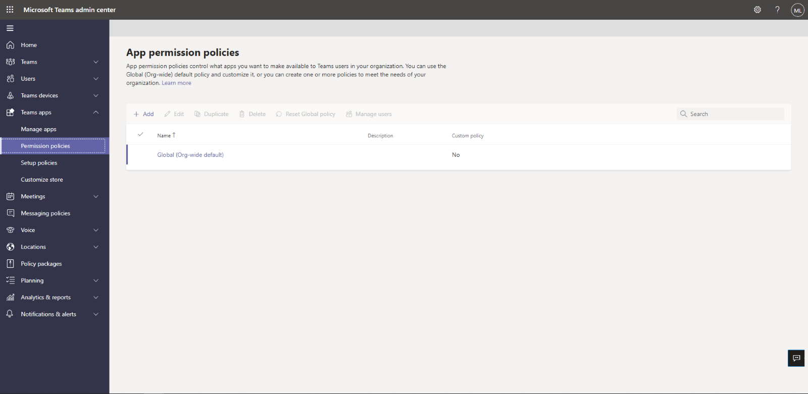

- Click on Global (Org-wide default)

- Under Third-party apps, ensure that Allow all apps is selected. Or, choose Allow specific apps and block others and search for MindGenius Online to add it to the list of approved apps.

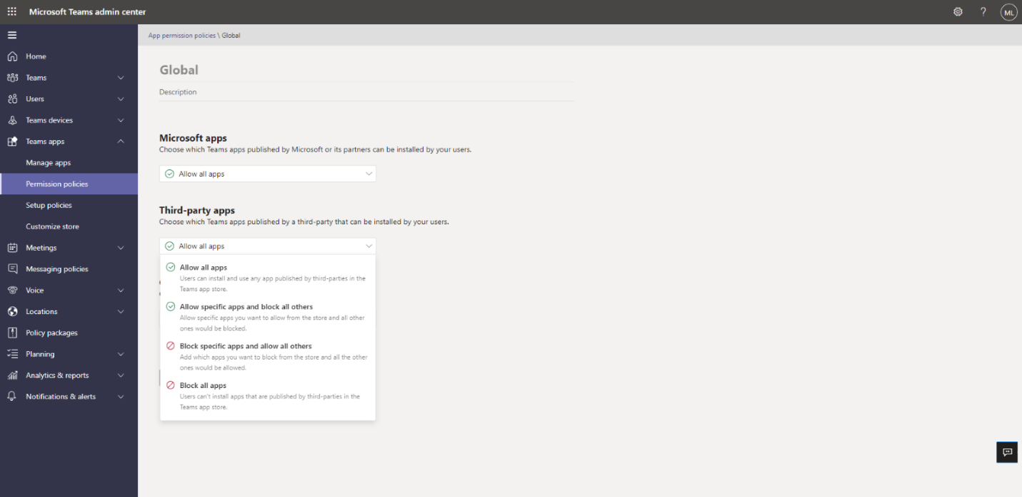

Enable MindGenius Online in Teams

- Select Manage apps and search for MindGenius Online

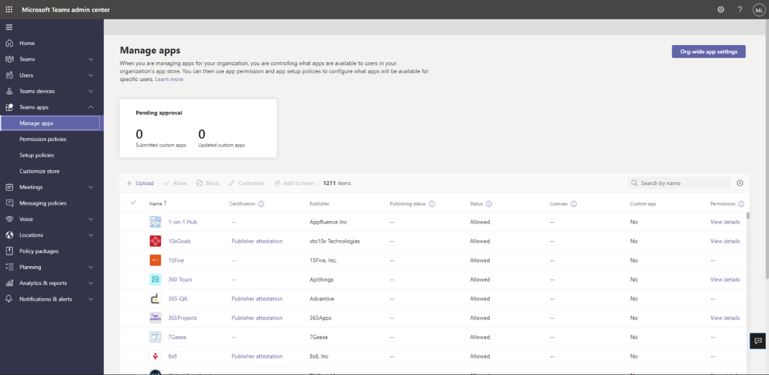

- Click on the check mark next to MindGenius Online and select Allow.
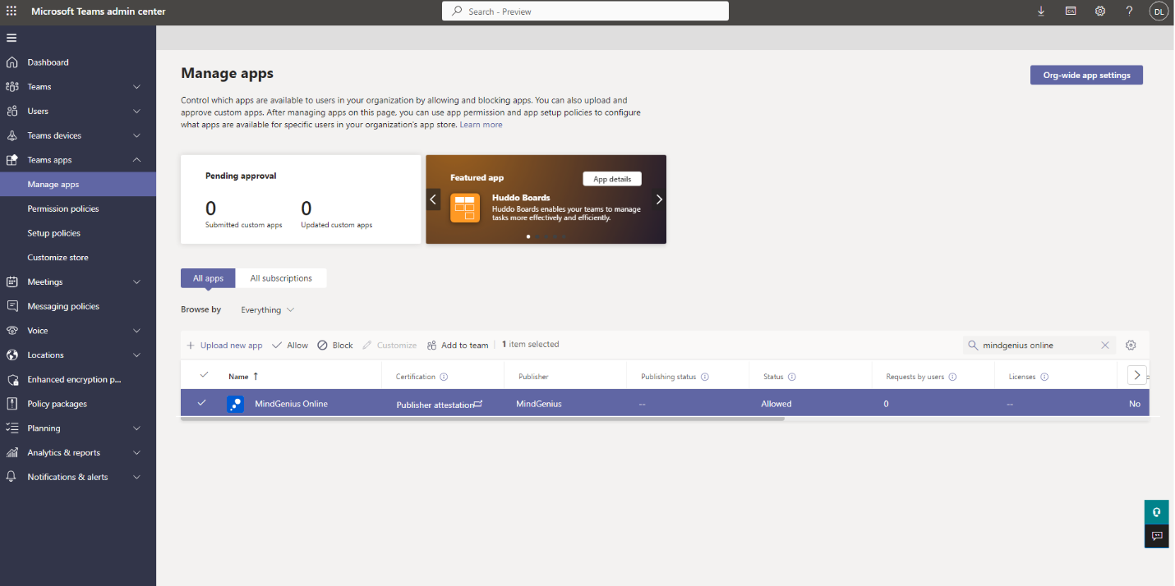

- Click Allow to let users access the application in Teams.

- Click on the application to (a) review and grant org-wide admin consent to permissions to access data and (b) view resource-specific consent (RSC) permissions for the application.

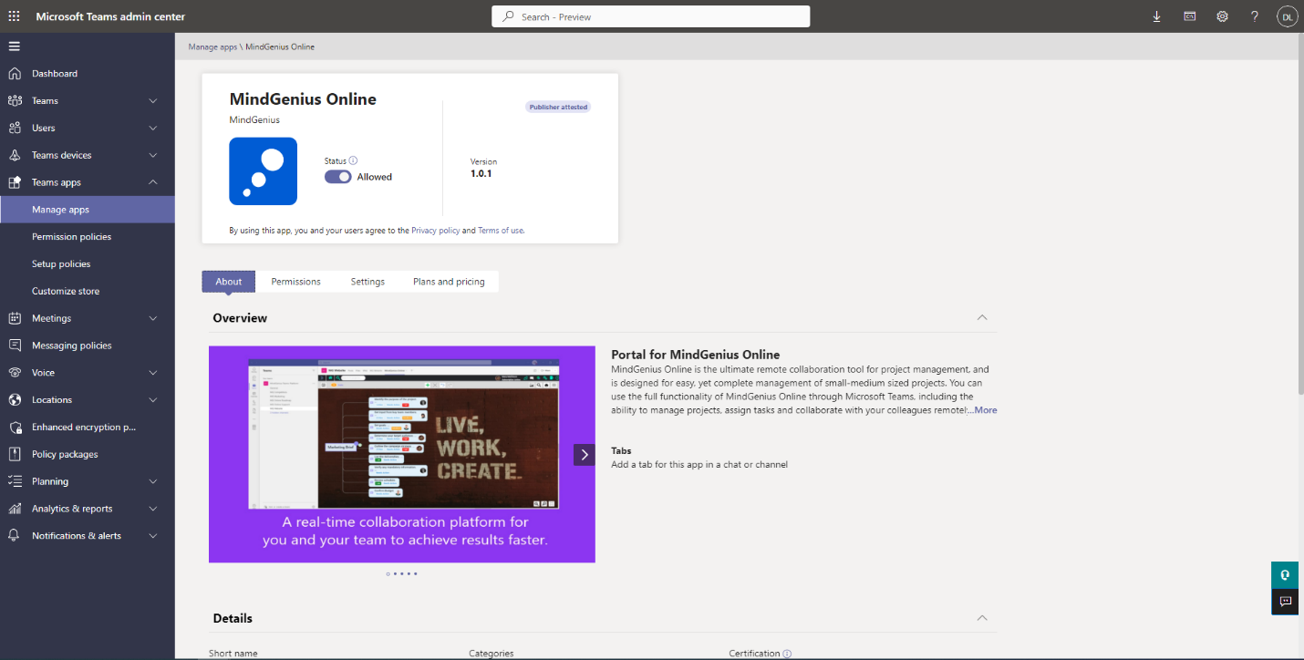

- Click on Permissions, then Review permissions to launch a new window with the requested permissions. Click Accept.

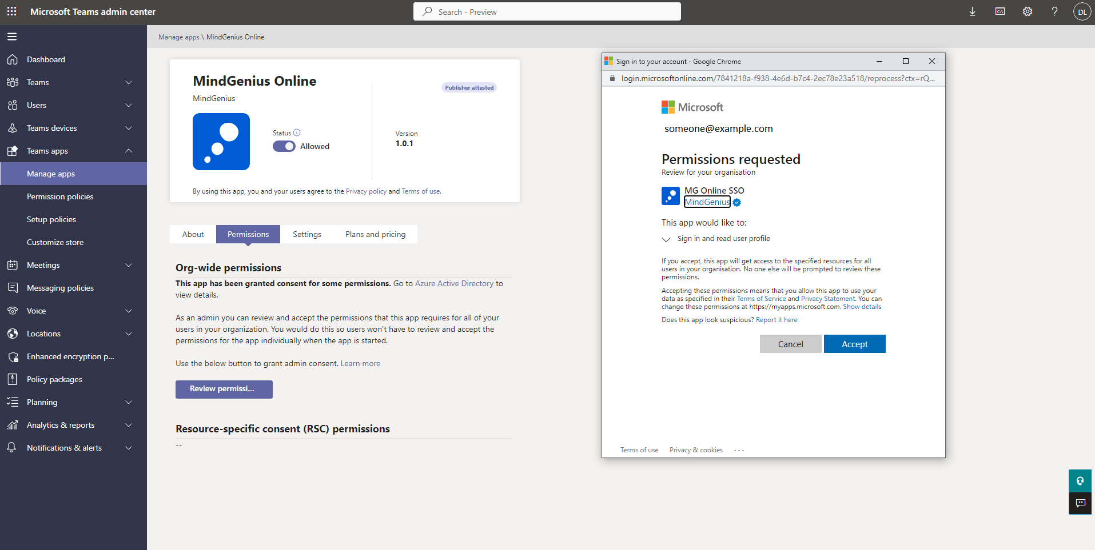

- If necessary, review the Settings for the application.

Troubleshooting and additional resources

- There are a number of help articles that relate to Frequently asked questions of the installation of MindGenius Online within Microsoft Teams Search FAQs

MindGenius Online for Microsoft Teams
Customer Support for End-Users and IT Admins

Where can end-users of Microsoft Teams get customer support for your app?
Via our manned support desk at info@mindgenius.com

What SLA do you have for responding to end-user raised customer issues via your support channel?
Office hours 9:00am-4:30pm Monday to Friday GMT – Response within the hour
Outwith Office hours Within the first hour of the subsequent working day

What is the escalation matrix for end-users to get faster response and resolution for their issues/queries?
Escalation is to Mr David Lenthall at info@mindgenius.com

Where can IT Admins of Microsoft Teams customer organizations get support for your app?
Via our manned support desk at info@mindgenius.com

What SLA do you have for responding to IT admin raised customer issues via your support channel?
Office hours 9:00am-4:30pm Monday to Friday GMT – Response within the hour
Outwith Office hours Within the first hour of the subsequent working day

What is the escalation matrix for IT Admins to get faster response and resolution for their issues/queries?
Escalation is to Mr David Lenthall at info@mindgenius.com

