Summary
MindGenius Ltd have put in place a policy and procedure for handling Subject Access Reports (SAR). Our customers have the right to ask for copies of the personal data we store and use. This is their right of access, also known as making a subject access request or SAR

Objective
This policy will document the process put in place within MindGenius Ltd to process and handle these requests. The policy and procedure will ensure that we satisfy the legal rights of all users as defined by ICO: https://ico.org.uk/your-data-matters/your-right-to-get-copies-of-your-data/

- Procedure

- MindGenius will ensure that there is a form available via the website to allow all users to raise a Subject Access Report
- All received reports will be processed by the Support Team using Zendesk via info@mindgenius.com
- We’ll normally respond at the latest within one calendar month of receiving a SAR request. There may be times when we need longer or we may need to charge a reasonable fee for admin costs. We’ll let the user know if this is the case.

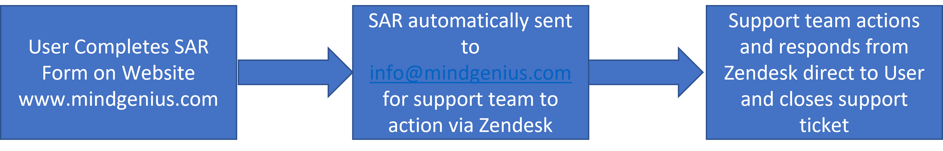

SUBJECT ACCESS REPORT FORM
- Who’s making this request?
We’re asking for your contact details so we can send your response and discuss your request with you (if needed). You only need to give us relevant details. For example, you only need to give us your postal address if you’d like us to respond by post or if you think it would help us identify you. We may ask you for proof of ID if we feel it’s reasonable and proportionate. The timescale for responding to your request will start when we receive this.
Your name |  | Contact number |  |  | Email address
Postal address

Are you making this request on behalf of someone else?
☐ Yes
☐ No (Please move to section three)

- Please provide contact details of the person you are making the request for.
If you’re making the request on behalf of someone else, we need to know who they are and their contact details in case we need to get in touch.
Name of other person |  | Contact number |  |  | Email address
Postal address
Other contact information for the person you are making the request for

You also need to give us proof of your authority to act on their behalf. For example, this could be written authorization from them or a relevant power of attorney.

Please send proof of authority together with this form when you make your request.
☐ Yes, I’ve got proof of my authority to act on someone else’s behalf and I’ll include it with my form. (Please move to section four.)
☐ No, I haven’t got any proof of authority yet, but will send it at a later date. I understand you can’t action my request until you receive this information.

- How would you like us to respond to you?
We’ll try and respond to you in the best way that suits you. Please let us know if you need us to make any adjustments for you eg large font.
☐ Email ☐ Post ☐ Other (please specify)

- What personal data are you requesting?
If you know exactly what personal data you’re looking for, it’s helpful if you let us know.
For example, if you need a specific email, we could search for this using a particular word or phrase.
Briefly describe your request

- Is there a date range of the personal data you’re asking for?
It’s helpful if you’re as specific as possible about your request. For example, if you’ve been a customer for several years, but you only need data about your recent purchase history, you could ask for data about things you’ve bought only in the last few months.

Date from |  | Date to

- Can you tell us anything else to help us with our search?
If there’s anything else of relevance you can tell us to help us identify you or the data you’re requesting, please include this here. For example, any aliases, date of birth, order number or a customer reference number.
Further information to help us find the data you need

Thank you. We’ll be in touch.

